029 Rhetoric and Research 02 - Introduction to Academic Research

What is Research?

When teachers and professors talk about research, they are talking about the direct and systematic examination of a problem or question, usually geared toward gaining or revising an understanding of its nature. Research is the core of academic inquiry: regardless of whether the discipline is history, literature, biology, psychology, or nursing, those who study in that discipline use the same essential tools to gain an understanding of it. Scholars collect facts, synthesize opinions, consider contexts, and analyze debates through a careful examination of many different kinds of research sources.

Primary and Secondary Sources

Writing effectively in an academic or professional situation typically requires that writers reference, and then respond to, critique, appropriate, analyze, or refute what others have written. The skill of understanding and integrating the work of others into one’s writing is a central requirement for success in academic writing: in many cases, this means making effective use of primary and secondary research sources. Each of these types of sources plays a crucial role in producing high-quality writing.

Primary Sources, as their name implies, are “first” sources, meaning that they are often “closest” to the subject being discussed. These sources tend to be produced directly by those involved in the event, activity, or controversy. These sources can be written documents, reports, objects, speeches, images or other forms of media, and they are in many cases unedited and offered without substantial interpretation or analysis. Think of primary materials as raw information before it has been commented upon. Examples of primary texts can include the following:
- First-hand, eyewitness descriptions of something
- Court testimony
- Memoirs or narratives of people involved in a controversy
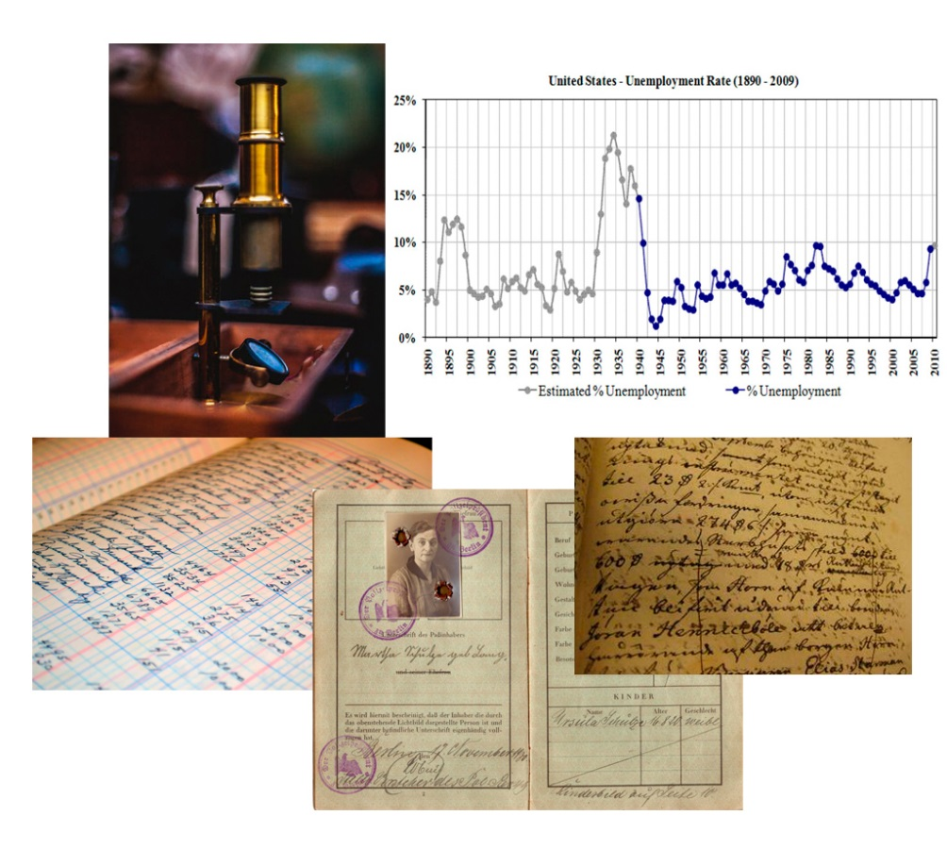
- Statistical data from a survey or experiment
- Photographs or video of an event or scene (i.e., like crime scene photographs, newspaper photos, or news / surveillance video)
- Artifacts collected at an archaeological site
- Physical evidence, like DNA, fingerprints, or fibers, from a crime scene.
- Interviews or transcripts
- The text of contracts and agreements
- Meeting minutes
- Correspondence between participants in an event or conflict (in the form of letters, email, memoranda, etc.)
- Research reports and scientific studies
- A work of fiction, poetry, or drama (when it is the object of study or analysis itself)
- The text of legislation, treaties, policy statements, or handbooks
Secondary Sources are acts of interpretation, analysis, summary, or commentary on primary sources. These types of sources are in many cases produced by researchers or writers who possess some specialized expertise or knowledge about the subject, including academics, scientists, commentators, media personalities, or columnists. Secondary sources, in most cases, are not produced by those directly involved in the event or controversy: they are often produced after the fact, by specialists who offer some type of opinion, context, or critical perspective on the subject. Examples of secondary sources include the following:
- articles in scholarly journals analyzing a literary work
- textbooks
- books covering / discussing the impact or causes of an historical event
- opinion columns in a newspaper or website that discuss or analyze a particular event or phenomenon
- articles analyzing a piece of legislation or a government policy
- a summary of a lawyer’s argument in a court case
- an interpretation of the requirements of a contract or treaty
- A magazine article that summarizes recent scientific findings

Distinguishing Between Primary and Secondary Sources
Exercise: Identifying Primary and Secondary Sources

For the ten sources listed below, indicate whether the source is a Primary or Secondary source.
- A transcript of General Wesley Johnson’s testimony to the U.S. Senate’s Armed Services Committee on June 12th 2004. ________________________
- An article by Jamie Knight on racist language in Herman Melville’s Moby Dick. ________________________
- A book by Andrew Bacevich called The New American Militarism in which the author analyzes recent trends in U.S. foreign policy. ________________________
- An interview with Corina Myovich, a Polish survivor of the Holocaust, discussing what she suffered at Auschwitz. ________________________
- Frederick Douglass’s autobiography, The Narrative of the Life of Frederick Douglass. ________________________
- Dr. Mary-Ellen Snow’s article in the journal Cancer Research Today surveying recent findings in the field of the molecular genetics of cancer cells. ________________________
- Economist Joanna Newcombe’s analysis on CNN’s Money Today on the financial impact of the 2010 health care overhaul. ________________________
- A series of thirty letters between the American writer F. Scott Fitzgerald and his wife Zelda sent during the Spanish Civil War (1938). ________________________
- A copy of the 1993 North American Free Trade Agreement. ________________________
- Jonathan Silver’s 2009 book on the use of imagery in the poem of William Wordsworth, Dancing Daffodils. ________________________

Popular and Scholarly Sources
While identifying a source as Primary or Secondary indicates the nature and function of the source—how close it is to the subject and what it is meant to accomplish—the source’s intended audience determines whether that source is a Popular Source or Scholarly Source.
Scholarly Sources are aimed at specialists and experts on a given subject—hence they are directed to “scholars.” These sources include academic and professional journals, books published by academic or university presses, scientific studies, and materials posted on academic or university websites. Scholarly sources are in general written by those with advanced degrees (professors, doctors, educators) or with specific kinds of expertise in their fields. The language of scholarly sources often is specialized as well, making use of terms and structures not found in everyday conversation.
Popular Sources, on the other hand, are addressed to more of a general audience—people who might have some interest in a given subject, but are not academics or experts in the field. National, large-circulation magazines such as Time and Newsweek , newspapers like The New York Times or Washington Post, television news, and most non-academic websites are considered popular sources. In many cases, popular sources are written by journalists or general writers, rather than professors or other academics. Popular sources are presented in language that is accessible to a broad audience: vocabulary, sentence structure, and other features of the text are in general very easy to understand.

Distinguishing Between Popular and Scholarly Sources

Exercise: Identifying Popular and Scholarly Sources

For the ten sources listed below, indicate whether the source is a Popular or Scholarly source.
- An article on the prevalence of eating disorders among California teenagers in People magazine. ________________.
- A National Science Foundation research study posted on NSF.gov on the correlation between drug use and early mortality among industrial workers in Ohio, Pennsylvania, and Kentucky. ________________.
- A column on the national debt by New York Times writer Paul Krugman, arguing that short-term deficits are actually helpful to the economy. ________________.
- The Postmodern Crisis, a book by Ronald McCarren, Ph.D., published by New York University Press. ________________.
- An article in The Atlantic Monthly magazine entitled “Do Video Games Teach Violence?” by journalist Amari Styles. ________________.
- “Save Me Lord, But Not Now: On Ironic Qualification in St. Augustine’s Confessions,” in the journal Religion and Literature, by Professor I.K. Zinn. ________________.
- An Online History of the 1381 Peasant’s Rebellion in England, a website presented by Stanford University’s Center for Medieval and Early Modern Studies. ________________.
- “Baltimore Crime up 10% in June,” a news article in the Baltimore Sun. ________________.
- Trends in Violent Crime in Baltimore City a report published in the National Journal of Urban Crime. ________________.
- “Living in the City: Costs and Benefits,” a blog entry by Caitlyn Korowski on her blog, “City Girl.” ________________.

Using Source Material: Summarizing, Paraphrasing, and Quoting

There are three central ways to make use of information that you find in primary and secondary sources: summarizing, paraphrasing, or quoting. Each method of using source material is appropriate for a different purpose.

Summarizing means putting the main points of a text in one’s own words, providing the reader with a direct statement of the overall main ideas of the text.

Summaries are much shorter than their source texts: often, writers might be summarizing in a few quick sentences an entire news story, the contents of a journal article, the substance of a book chapter, the main points of a research report (when appended to a research report, this summarizing is often called the “executive summary”), or even the entire plot of a novel. Think of summarizing as providing the reader with a quick abstract of the source: the summary doesn’t have a lot of detail, but is rather a broad and general statement of the basics.

Consider the following quick summaries for a general idea of what a summary looks like. Note that each of the source texts (regardless of whether they are primary or secondary sources) can be rather long; the summaries below cover an entire movie, the contents of a scholarly book, a journal article, and a complete speech.

Spike Lee’s 1989 film Do The Right Thing is the story of the Brooklyn neighborhood of Bedford-Stuyvesant. The story centers on Mookie (Spike Lee), his boss Sal (Danny Aiello), and the complicated racial and ethnic conflicts that structure many urban communities.

David Grossman’s book On Killing suggests that the U.S. military’s use of the psychological tool of operant and reflex-oriented conditioning has provided a significant increase in the lethality of the typical American soldier. Further, Grossman also argues that the same techniques are being taught to teenagers in this country through mass-marketed violent video games.

In her article, “Urban Politics and Public Health in Baltimore, MD,” sociologists Liz Wasserman argues that an unwillingness on the part of local governments and community action networks to fund prevention programs has hurt the overall health of urban populations, particularly in regard to addiction and sexually transmitted diseases.

Letter from a Birmingham Jail is Martin Luther King’s impassioned defense of his tactics of civil disobedience and immediate direct action against discrimination and civil rights abuses in the 1960s American south.

Paraphrasing is used when writers want to make use of a smaller or more narrow passage in a given primary or secondary work. Paraphrasing doesn’t provide the reader with an overview of the entire contents of a text, but rather brings a reader’s attention to a specific point, perhaps through a passage that illustrates one of the text’s main ideas. Paraphrases are roughly the same length as the original passage, but are in the writer’s own words.

Take, for example, this small section of Malcolm X’s famous speech “The Ballot or the Bullet” (1964).

Now in speaking like this, it doesn't mean that we're anti-white, but it does mean we're anti-exploitation, we're anti-degradation, we're anti-oppression. And if the white man doesn't want us to be anti-him, let him stop oppressing and exploiting and degrading us.

Here’s a paraphrase of the same passage. Note that the passage conveys the same information as the original, but in different words. It is equally descriptive and specific, and is roughly the same length as the source passage.

Malcolm X says in his speech that those who are in favor of African American Civil Rights are not necessarily racist against white people, but rather that they are against the abuse, humiliation, and repression that African-Americans suffer under a white-dominated culture. He also says that if white people do not want African-Americans to be anti-white, they should stop perpetuating the things that keep black people down.

Quoting is one of the most common and direct methods of using research material. But it is one of the most overused. One should quote from a text when the source’s specific wording is particularly important or effective for one’s purpose. Statistics, assertions of fact, and direct statements of one or more of the source’s main points are all elements of a source text that might be appropriated in a quote. A quote is also a way to borrow the credibility of the source text’s writer or speaker—a direct quote in effect uses the authority of the source text to make the essay’s point more effectively.

Quotations from a text must be exactly in the original words, and must be punctuated properly. Material taken from a source text goes inside quotation marks. See the following examples for the proper format of quotations:
- “Quoted material should always go inside quotation marks, including the original punctuation.”
- When only part of a sentence from a source text is used, “one should still use quotation marks around whatever is appropriated.”
- “The same rule holds true,” even when the partial quote is used at the beginning of a sentence.

Whatever method you choose to employ in using research materials—summarizing, paraphrasing, or quoting—there is a basic strategy to follow in order to make that material flow seamlessly with the ideas in your own original writing. This is called the IQCC method, and it is discussed in the next section.

Using Primary and Secondary Evidence Properly: The IQCC Method

A big problem with many student papers is the improper or ineffective use of material quoted, paraphrased, or summarized from another source. Often, information from other sources is not used effectively—it is either not introduced properly, not contextualized adequately, not commented upon sufficiently, not formatted correctly, or its source is not cited.

An easy strategy to remember when using ANY material from a source other than your own brain is the following: I call it the “IQCC” strategy. This stands for a series of steps that will enable you to use your quoted, paraphrased, or summarized evidence for the maximum possible effect. The steps are:

Introduce: Set up and contextualize your quoted material, with a signal phrase.
Quote, Paraphrase, or Summarize: Insert and punctuate your appropriated material properly.
Comment: Explain your quotation further, and make it relevant to your thesis.
Cite: Attribute your material properly, using MLA Citation Style and a Works Cited page.

Introduce:
When you use something from another source, you need to make clear that you are doing so, usually using a “Signal Phrase.” More information on Signal Phrases is included in the next section. This tells the audience a.) that you’re using material from another source, and b.) the specific source itself. Example: [Introductory phrase] A great example of how Higher Learning examines the flaws in the assumptions of college students is shown in the beginning of the film: Malik (Omar Epps) states to his professor that he should be graded differently “because we come from the same place” (Higher Learning). ]

Quote, Paraphrase, or Summarize:
This is where you actually use your evidence from your source text, inserting and punctuating it properly. A summary or paraphrase, which is in your own words, can be placed directly after the introductory phrase. If the evidence is a quotation, the quoted material goes inside quotation marks, with a citation at the end of the sentence. Example: At the end of the film Higher Learning, Malik shows that he has really grown, bonding with Kristen in the aftermath of Remy’s shooting. He says to her: “I guess this thing affected all of us, no matter what color we are. We just have to learn to get along” (Higher Learning).

Comment:
This is where you analyze the importance of the quoted, paraphrased, or summarized material, examining it in detail and fitting it into your argument as a whole. This usually takes the form of a couple of sentences after the inclusion of the quoted, paraphrased, or summarized material . Example: Malik says at the end of the film, “I guess this thing affected all of us, no matter what color we are. We just have to learn to get along” (Higher Learning). This quote shows that Malik has grown over the course of the film, being transformed by Remy’s shooting. Learning to relate to others is an important lesson for Coppin State students because . . .

Cite:
This is where you give your source for your information, in proper MLA style. This must be done in MLA In-Text Citation Format. More information is provided on this in the section of this text on citation procedures.

MLA In-Text Citations are designed to direct your reader to the appropriate entry in the Works Cited Page. You must give your reader enough information to find for him or herself the information that you use.

The most direct way to indicate that you’re taking material from another source is to use a Signal Phrase incorporated within your prose. A signal phrase cues the reader to the fact that you are using someone else’s material:

Professor Phipps makes a devastating comment to Malik early in the film: “So, Mr. Williams thinks I am an Uncle Tom, hmmm? Well, well, well. What does that have to do with your ability to place a comma in its proper place or put a period at the end of a sentence, hmmm?” (Higher Learning).

Judith Thomson states in her article, “I’m proud to be a gun owner” that owning a weapon “can improve a woman’s self-confidence in a male-dominated world” (Thompson 256).

Citing from Books or Articles

The proper citation for a book is to use your signal phrase, followed by the author’s last name and page number in parentheses. Example:

One resultant characteristic of an experience like September 11th, Neil Smelser suggests, is the emergence (or rather resurgence) of what he terms “primordial cultural themes,” an “old-fashioned” getting-back-to-basics impulse defined by: “a reassertion of the virtues of nation and community; unashamed flag-waving patriotism, and a feeling that we, as Americans, under attack, were one again” (Smelser 270).

Rush Limbaugh claims in his recent book, I’m Just a Guy Who’s Afraid of Change, that too much pasta CAN be a good thing (Limbaugh 883).

Citing From Films

The proper in-text citation for a film is simply the film’s title, in italics, included after the relevant text.

The question asked by the “old” Ryan at the end of Saving Private Ryan, “Tell me . . . have I lived a good life, am I a good man?” simply ruined the film, overwhelming the viewer with ham-handed emotion (Saving Private Ryan).

Introducing Quoted, Paraphrased, and Summarized Material: Using Signal Phrases

When using quoted, paraphrased or summarized material in an essay using the IQCC method, one of the key tasks is introducing the material appropriately. One way to do this is to use Signal Phrases to identify the source and type of information (facts, opinions, observations, etc.) and to help readers distinguish the author’s information from your own.

Using Signal Phrases effectively prevents you from “dropping” or “floating” quotations—putting them in an essay without sufficient context—which can confuse a reader and make them think that a specific idea or opinion is yours when, in fact, it comes from a source.

As a general rule, Signal Phrases include the author’s name and an active verb that indicates that the information came from that source. Varying the wording and placement of Signal Phrases can avoid repetition and give your writing a fresher, more original feel. Here are some sample Signal Phrases:

- Anderson and Collins believe that “…” (97).
- As Jose Malinado observes, “…”
- Sendhil Khalizad, Associate Professor of Arabic Literature, proposes that “…”
- “…,” adds Connie Walinsky, “but …” (441).
- “…,” according to Senate Majority Leader Mitch McConnell.
- CNN reporter Miguel Zapatista offers another perspective: “…”

Common Verbs Used in Signal Phrases

Below is a list of verbs that are commonly used in Signal Phrases. Each of these verbs is a variation of the verb “to say.” Words like these indicate to your reader that the ideas or information that follows come from a source and are not your own ideas.

acknowledges | argues | compares | debunks | disputes | explores
accepts | asserts | concedes | declares | emphasizes | follows
adds | believes | confirms | defends | elucidates | grants
admits | claims | contends | demonstrates | endorses | illustrates
agrees | comments | critiques | denies | evaluates | implies
refutes | rejects | reports | responds | states | suggests
Insists | justifies | juxtaposes | notes | offers | thinks
observes | points out | proposes | questions | recognizes | writes

Introduction to Modern Language Association (MLA) Citation Procedures

When writers use information from any other source, be it primary or secondary, popular or scholarly, that information must be attributed to the person who originally wrote it or said it. Writers give credit to those whose information they appropriate through clearly citing that information with standard documentation procedures.

Modern Language Association Documentation

The Modern Language Association (MLA) is a professional association of scholars—usually college and university-level professors—in English, literature, and other languages. This association is responsible for establishing professional standards for research in its constituent disciplines. This includes setting guidelines as to how scholars present information about the primary and secondary sources they use, both to each other and to the world at large. These guidelines govern a.) which information researchers must provide regarding their sources and b.) in what way that information must be organized, formatted, and presented.

The reason for these guidelines is to standardize the exchange of information about sources between scholars. If scholars adhere to the standards of MLA Documentation procedures, anyone who reads their work will be able to identify consistently the specifics of any given source—who wrote it, where it was published, which edition the scholar used—and easily access the same source.

Why Document Sources?

Writers document sources for several reasons:
- To clearly identify the source of any information in their work;
- To delineate between the ideas of the writer and the ideas taken from a source;
- To avoid plagiarism—representation of someone else’s work as their own—or the appearance of plagiarism;
- To enable readers to verify for themselves the accuracy of information taken from any sources present in the work.

How Do We Document Sources?

In MLA Documentation Style, there are two primary means of documenting sources: MLA Works Cited / Bibliography Citations and MLA In-Text Citations. Each of these citation procedures serves a different but related purpose.

MLA Works Cited / Bibliography Citations

An MLA Works Cited page is a listing of all the primary and secondary sources present in a given work. This page provides the reader with detailed information about each source the writer used in the construction of the paper. Using an MLA Works Cited page, any reader should be able to access, using a library or other resource, each source that the writer references in the paper.

MLA has determined specific formats for each kind of source—journal articles, books, newspaper articles, web pages, films, magazine articles, sound recordings—that provide the reader with the necessary information to find the specific source referenced by the writer. The MLA Handbook for Writers of Research Papers contains an exhaustive and official list of the formats required for each type of source.

Below are some of the more common academic sources and their required MLA Works Cited formats. Think of these formats as templates: once you know them, you can simply fill in the blanks with the information that MLA requires for each source.

Book:
[Author Last Name], [Author First Name]. [Title of Book in Italics]. [Publisher], [Year].

Examples:
Hill, Matthew. The War on Terror and American Popular Culture. Fairleigh Dickinson University Press, 2009.
McCarthy, Cormac. The Road. Alfred A. Knopf, 2007.
Morrison, Toni. Beloved. Random House, 1987.

Journal Article:
[Author Last Name], [Author First Name]. “[Title of Article].”[Journal Title in Italics], vol. [Volume #], no. [Issue #], [Date], [Journal Pages].

Examples:
Van De Lay, Arthur. “Exposing the Human Fund.” Journal of Non-Profit Ethics vol. 32, no. 3, Fall 2003, p. 23-44.
Slotkin, Richard. “Unit Pride: Ethnic Platoons and Myths of National Identity.” The Journal of American Culture, vol.10, no. 1, September 2001, p. 123-135.
Hill, Matthew. “’I am A Leaf on the Wind: Cultural Trauma and Mobility in Joss Whedon’s Firefly.” Extrapolation, vol. 50, no. 2 (2009): 222-254.

Website

Author Last Name, Author First Name. “Article Title.” Title of Website in Italics. Date of Article, URL.

Smith, Roderick. “Analysis of Fake News in the 2016 Estonian Presidential Primaries.” Baltic Politics Today. June 30, 2017, http://www.balticpoliticstoday.com/article/2300323

Tapper, Jake. “And Another Thing.” CNN.com. March 11, 2018. http://www.cnn.com/commentary/tapper/023313

Editorial. “We Must Re-Learn Civility in Politics.” Mic. August 4,2018. http://www.mic.com/header/2w31d/2343/

Film:
[Title of Film in Italics]. Dir. [Name of Director]. Perf. [Name of Star 1, Name of Star 2]. [Production Company], [Year of Production].

Examples:
Avatar. Dir. James Cameron. Perf. Sam Worthington, Sigourney Weaver. Universal Pictures, 2009.
Red Dawn. Dir. John Milius. Perf. Patrick Swayze, Jennifer Grey. Tri-Star Pictures, 1984.
The Social Network. Dir. David Fincher. Perf. Jesse Eisenberg, Justin Timberlake. Columbia Pictures, 2010.

MLA In-Text Citation

In-Text Citations are designed to direct your reader to the appropriate entry in the Works Cited Page. You must give them enough information to find for themselves the information that you use.

The most direct way to indicate that you’re taking material from another source is to use a Signal Phrase incorporated within your prose, which is discussed above. A signal phrase cues the reader to the fact that you are using someone else’s material:

Judith Thomson states in her article, “I’m proud to be a gun owner” that owning a weapon “can improve a woman’s self-confidence in a male-dominated world” (Thompson 256).

Carson McCalister claims in his recent book, I’m Afraid of Change, that too much pasta CAN be a good thing (McAlister 883).

Recent studies have suggested that women who own high-caliber weapons are much less likely to feel unsafe in their own homes, regardless of what any data says to the contrary (D’Souza 448).

Citing from Books, Journal Articles, and Most Other Print Sources

The proper citation for a book is to use your signal phrase, followed by the Author’s last name and page number in parenthesis. Example:

One resultant characteristic of an experience like September 11th, Neil Smelser suggests, is the emergence (or rather resurgence) of what he terms “primordial cultural themes,” an “old-fashioned” getting-back-to-basics defined by: “a reassertion of the virtues of nation and community; unashamed flag-waving patriotism, and a feeling that we, as Americans, under attack, were one again” (Smelser 270).

James Joyce writes in “Araby” that, for his narrator, Mangan’s sister’s name “was like a summons to all my foolish blood” (Joyce 4).

Citing From Films

The proper in-text citation for a film is simply the film’s title, italicized, included after the relevant text.

The question asked by the “old” Ryan at the end of the Saving Private Ryan, “Tell me . . . have I lived a good life, am I a good man?” simply ruined the film, overwhelming the viewer with ham-handed emotion (Saving Private Ryan).

