019 Grammar 01 – Intro to Grammar and Mechanics

What is Grammar?

Many students think about “grammar” as a large number of complicated rules that govern how people talk, and more importantly, how they should “write” correctly. But that conception of grammar is only half true. Language does indeed work by rules—any speaker of a given language intuitively knows dozens of them without even trying to.

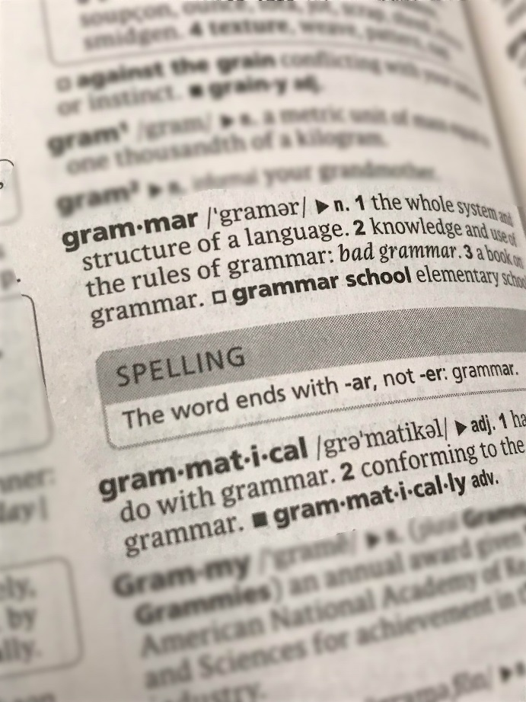
Dialects, regional or local variations of languages, also operate by a set of rules. Many people from the west side of Baltimore, for example, speak in a noticeably different manner than those from more rural areas, such as the Eastern Shore. “Ebonics” is different from southern American slang and from the rural dialects of western Minnesota, which is in turn starkly different from how people in London or Edinburgh, Scotland, speak. All speak English, but in different dialects. Any careful listener will notice differences in vocabulary, sentence structure, pronunciation, and inflection.

The dialect of English that is used most commonly in the United States is Standard English Grammar. It is the dialect in which a large amount of business is conducted, and in which most widely-circulated publications and public documents—like contracts and legislation—are written.

Why is Standard English Grammar (SEG) Important?

Displaying a mastery of the conventions of Standard English Grammar (SEG) signifies to a reader that the writer of a given piece understands the requirements for conducting professional, academic, or public discourse in a manner that is rhetorically appropriate.

The following chapter sections provide an overview of the most common errors in Standard English Grammar (SEG) present in Coppin State University student papers.

