018 Composition 08 - The Writing Process: Proofreading

Overview

Proofreading is one of the final steps in the writing process. In this step, a writer is looking only for mistakes in grammar, usage, spelling, punctuation, and typing. This step is different than editing, in that the writer is not trying to correct problems of focus, evidence, coherence, or detail—the only concern is whether the writing, as committed to paper, is correct.

There are several methods that are effective for proofreading your papers. These include:
- Reading Aloud
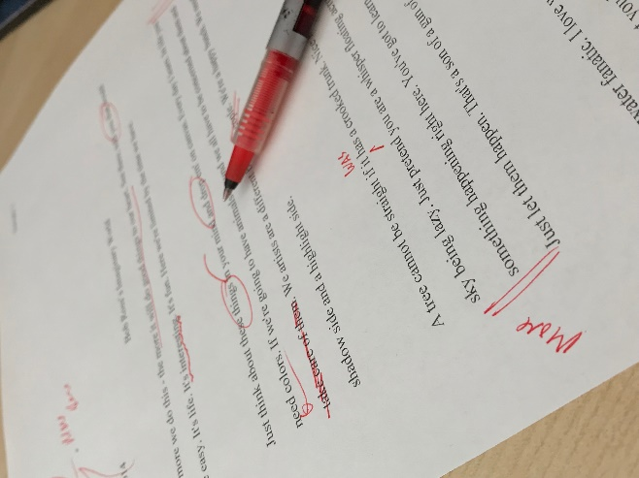
- Assisted Reading Aloud
- Re-Lining the Draft
- The Mark Method

A key to good proofreading is knowing first what to look for. Being conscious of what kinds of errors you consistently make (look carefully at the comments your instructor gives you on your drafts) will help you greatly. Focus first on your known habits of error, then move on to more general problems.

Reading Aloud
Many times, reading a piece of writing aloud to someone else, very slowly, will enable a writer to hear some of the incorrect or missing words, verb tense or possession errors, and problems in sentence structure in the paper. This method is only partially effective when a writer is reading his or her own work. Many writers as they read their own work, simply won’t see their own errors; they will often read aloud what they think should be on the page (i.e., a correct verb tense or correct possessive form) rather than what they actually wrote. This is why reading others’ work aloud is often far more effective: when the reader has a sense of distance—when he or she does not know exactly what the writer wanted to write in each sentence, it is easier for the reader to see—and correct—what is actually on the page.

Exercise: Proofreading by Reading Aloud

Read the following passage aloud to see how many errors you can find (there are 8):

Rafael went over to Layla house other day to swim in her swimming pool. First, Rafael and Layla swimmed around for a while and play volleyball. Than, they get out the pool and lay out in the sun on the deck. After a half hour of laying in the sun, Layla an Rafael got hot and get back in the pool

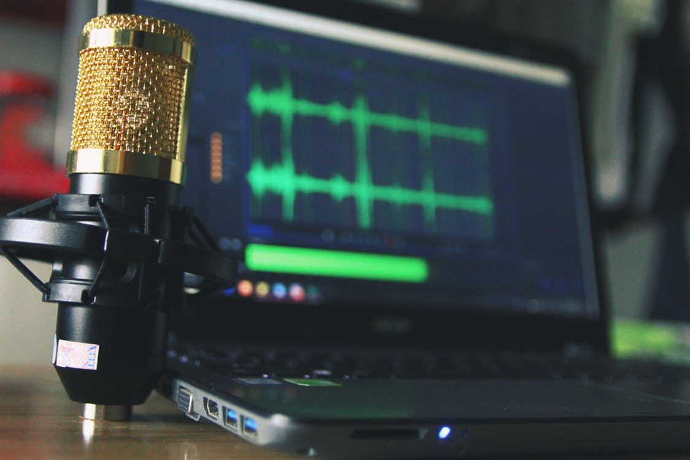
Try reading your own work aloud very slowly—about half normal speaking speed—and see how many errors you hear.

Paired or Assisted Reading Aloud
This is an even more effective means of proofreading. Having someone else—preferably someone who reads well (and often)—read your work aloud to you will often enable you to hear errors you might not otherwise hear.

If a reliable reader is unavailable (or inconvenient), there are computer programs such as
- ReadAloud (https://www.microsoft.com/en-us/p/readaloud/9wzdncrdn3ms?activetab=pivot:overviewtab )
- NaturalReader https://www.naturalreaders.com/
- Some other options are available from other providers: https://www.techradar.com/news/the-best-free-text-to-speech-software

Exercise: Proofreading by Assisted Reading Aloud

Have someone read the following passage to you to see how many errors you can pick up (at least 8 errors present). Or, enter this passage into NaturalReader or ReadAloud and do the same thing.

Today American military budget is complete out of control. According to the last published report, America spend like 1.7 trillon dollars on defense in 2010. To put this in perspective the America government spent only 300 billion dollar on education. That means that for every man woman and child in America the government spend $5,000 on defense. Is this worth it, ask normal people?

Re-Lining the Draft

Many writers find it easier to identify grammatical errors in their work when they look at sentences, rather than paragraphs, in their work. Think, for example, how much easier it is to identify an incorrect sentence on a grammar worksheet than in your own paper.

An effective way to isolate the sentences in an essay is to re-line your draft, putting each sentence on its own line. Save a new copy of your paper, and then hit “Enter” twice at the end of each sentence. Then, read each sentence very carefully, looking for and correcting grammatical errors—especially the ones you know you are in the habit of making. Once you have corrected the sentences on the re-lined draft, make the changes to your main copy.

Exercise: Proofreading by Re-Lining the Draft

Below is a re-lined section of a paper draft: does the reorganization of the lines help you see anything you missed? (12 errors total below).

Same-sex marriage should be legalize in Maryland.

While I understand that many peoples might not like the idea, it is not the place of the government to tell people who they can and can’t not love.

Those who disagree wth same-sex marriage need to understand that, as far as the state in concern, marriage is a contract between two people, not a religious sacrament.

This “civil marrage” is an agreement between two people to share wealh and property, to care for each other, and to make joint decisions.

This agreement of course come with specific benefits, like for taxes, hospital vistatin, and inheritance.

Denying people the right to enter int these kids of agreements is not just unfair, it is un-American.

The Mark Method

Many readers miss errors when proofreading simply because they read too quickly. The “Mark Method” is a proofreading technique that helps readers slow their reading speed down and pay attention to detail. As its name suggests, the “Mark Method” involves making physical marks on a draft.

To use the “Mark Method,” read your draft aloud very slowly, with a pen in hand. As you read each word, scribble a small line underneath its entire length, taking about one full second for each scribble. Do this for every word in your draft. Putting a small line under each word, as you read it, will force you to spend more time on actually reading each word as it exists on the page.

Exercise: Proofreading with the Mark Method

Try using the Mark Method on the passage below (12 errors total below).

There are several reason why the University should build more on campus parking. First, it will increase student retentions by makking it easier to students to get to class. Right now student often have to drive around for least half an hour to find a parking space, which makes it hard for students to get to class on time. Second, it will improve student security by allowing more students to park oncampus. We all know that the surrounding area are not the safest, epseicially for students taking night class. Last, more parking will enabel the University to easily host events, like professional meeting and conferences, that will generate money and prestige for the school.

Exercise: Proofreading by Any Means Necessary
Proof the following passage using whatever method you find most useful. There are a total of 24 errors in this passage. Identify and correct them.

For our first English 101 assignment, Dr. Pineiro had us write a thousan word essay on an experience that in some way kind of transformed or change our lives. My essay was actual about 900 words. We also learn a lot about the writing process in Dr. Piniero class. To generate ideas, I primarily used brainstorming and questioning for my paper, because I had hard time chosing a topic. By writing lists of ideas and questions, I came up with the idea of writing about my first day of high school, it was one of the worst days of my life, but of course one of the most transformative. After I decided on that topic, I started going through the day itself. I Outlined the major events of the day and set them up in chronological order. Getting up early, being overwhelmed in my third period physics class, sitting all alone at lunch because no one knew me, and finally missing the bus on the way home. I then try to remember the characters and people involved in each little scenes. Once I had the basic timeframe of the paper written out, I tried to write good topic sentences for each of the paragraphs in my essay, I tried to follow the rules of good topic sentences like we discussed in class, but it was hard. Eventually I had about seven paragraph telling about my day, each one started with a good strong topic sentence that outlined the reason for the following paragraph and what I had to say about that experience during the day. I turned in the paper and was sure I would get a “A.” After getting the grade (a C minus), I got back to work; I looked back over my first draft and tried to get rid of information that didn’t directly address my point. I was careful about profreading the second draft too.

